Project Design Phase-I Problem Solution Fit

|  |  |
| --- | --- |
| Member | TONY DAVID RAJ M  SHANKARESH R  UDAYA KIRAN S  SHANJAY V |
| Team ID | PNT2022TMID13856 |
| Project Name | Project – Inventory Management System for Retailers |
| Maximum Marks | 4 Marks |

Retailer who need to manage their inventory and further management for stock through software application.

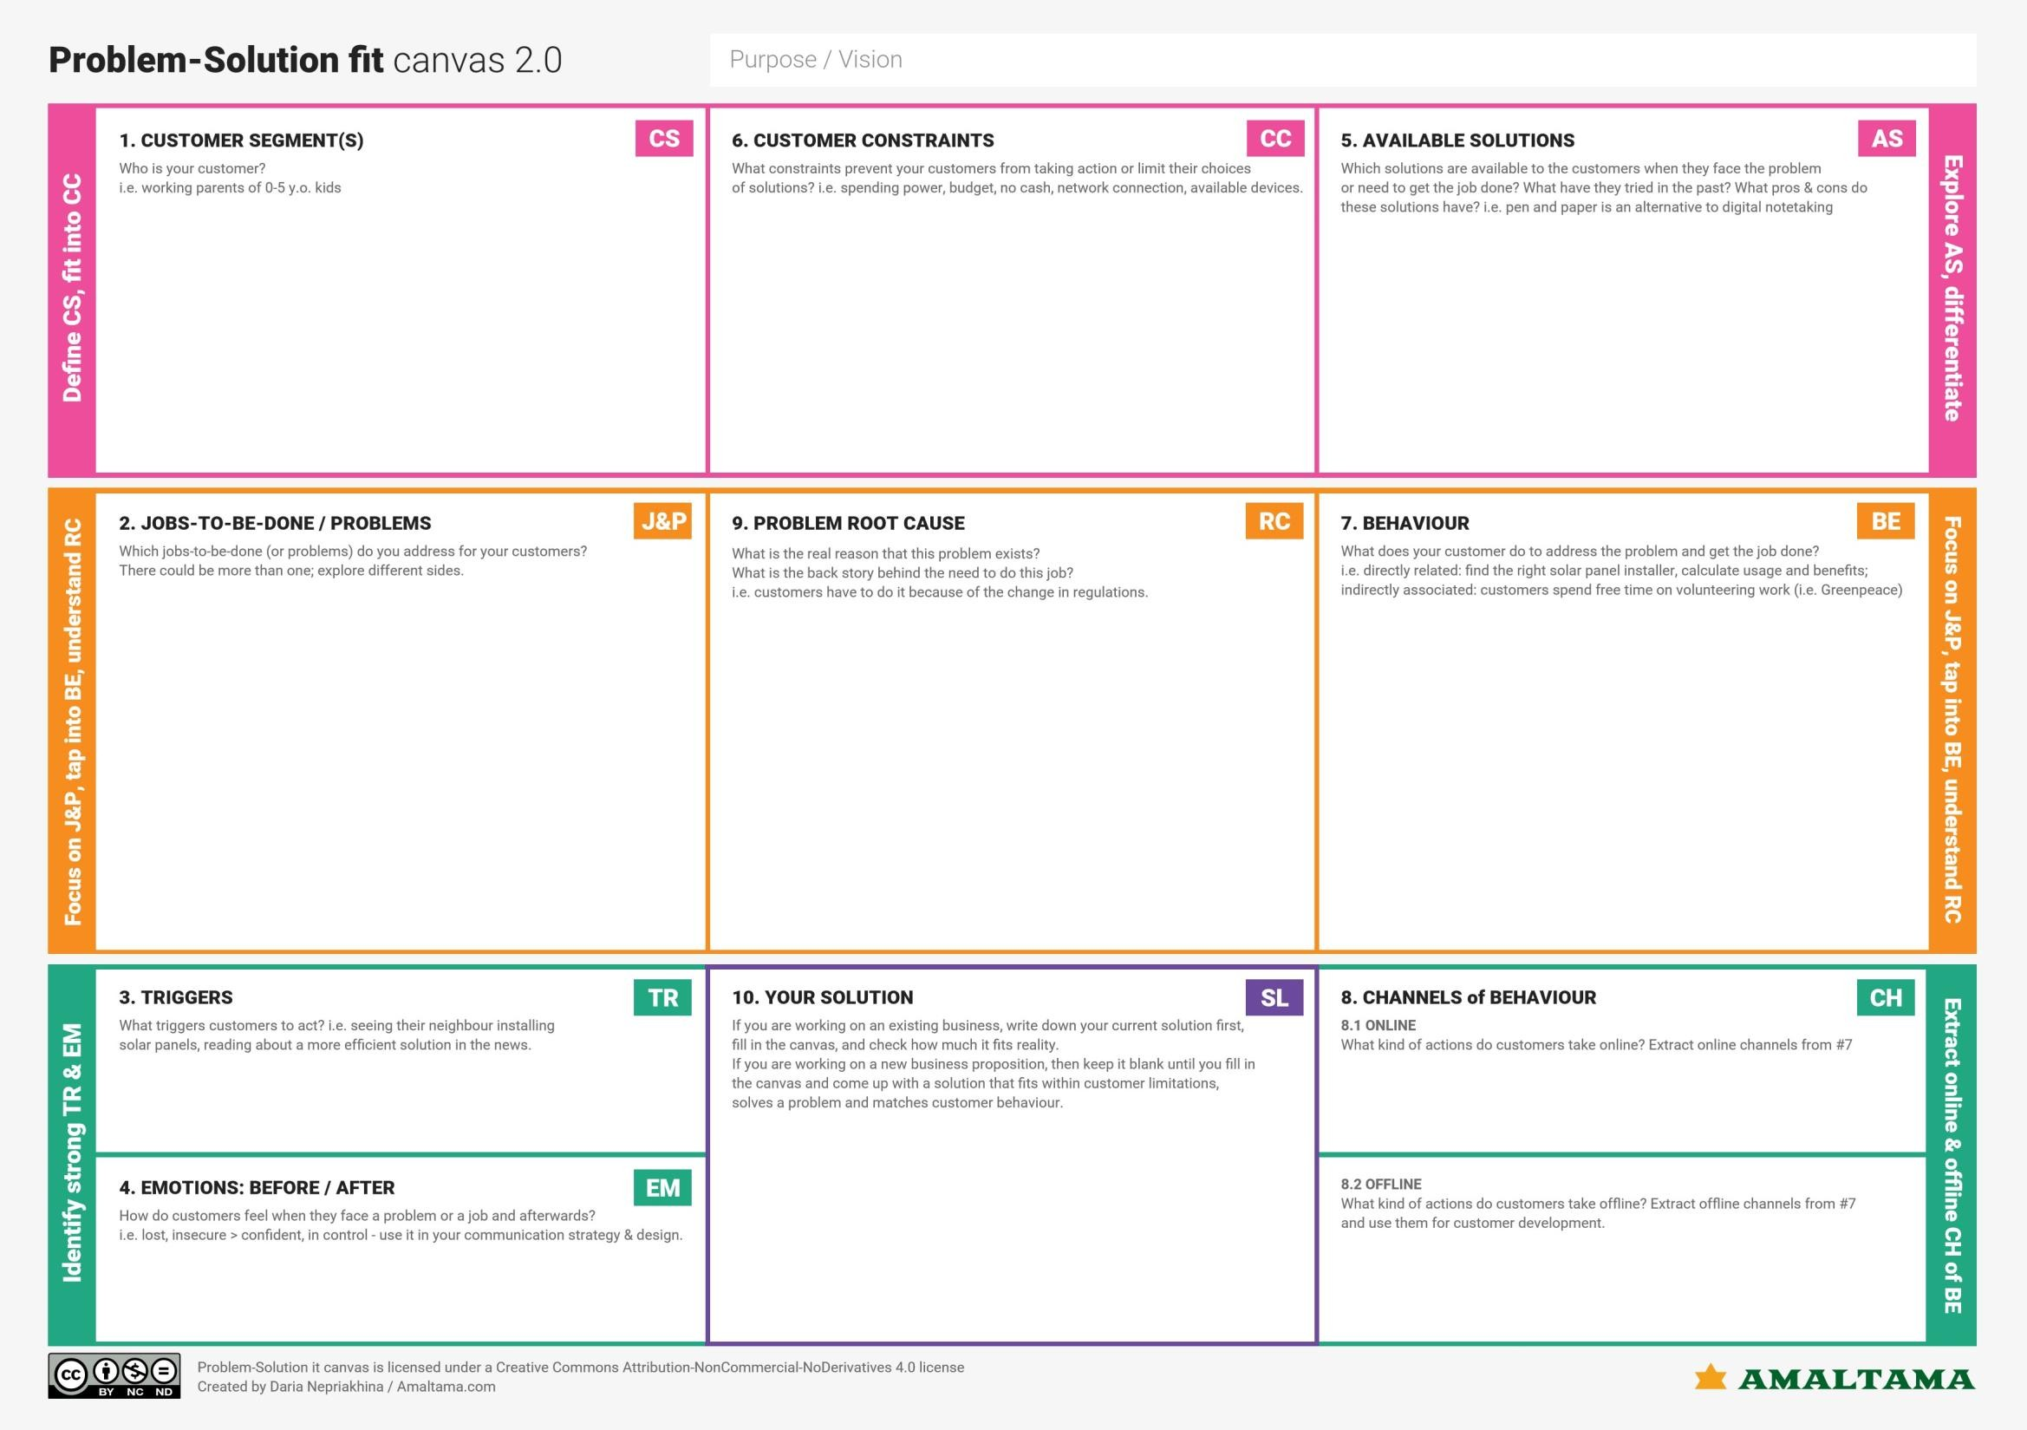

Poor demand prediction

Avoid Overstocking and Understocking Chalenges in stock management

Need knowledge to maintenance

Maintain the huge record by a single person.

Before – worried, Frustrated, Lack of knowledge of about stocks

After- Happy, Flexible, Profitable

Delivery Delay

Changing the price of stocks Network Problem

Openness to availability

Control information

Absence of real time inventory

Develop a cloud application that “ Tracks real time inventory such as purchase details and stock availability details and suggest to reduce the spending amount for buying new stocks”.

Hiring employees and accounts to maintain stock

Management of log books in standard way Usage of 3rd party inventory websites

Information is essential for the creation and improvement of the application

All inventory details available

SMS notification for inventory